Membership
The Club numbers about 100 people from all walks of life. Anyone interested in the club’s activities is welcome to join the club or come to any of our meetings. Meetings are usually held at 7:00 pm on the fourth Thursday of the month at the Camden Rod and Gun Club located on Moran Post Road. To join the club, visit the website and fill out a membership form or call one of the club’s officers. Feel free to attend any of our meetings. Dues are only $15 per year.
The Club has been placing Atlantic salmon fry into Fish Creek and its tributaries since 1997. We place at least 35,000 Atlantic salmon fry in Fish Creek each year. The public is invited to help the club with the stocking, the date of which will be available on the website but is usually in early July.
The state has mandated testing of our fish, so all of the Atlantic salmon the club stocks are disease free from VHS and other aquatic diseases.
Anglers are asked to call one of the Club’s officers to report catches of Atlantic salmon anywhere in the Oneida Lake watershed. We hope you return all Atlantics unharmed to support of restoration. Legal size of Atlantic salmon in inland water ways is 15 inches.

Officers
- President: Jim Lawler
- 315 964-2888
- Vice President: Tom Schneider
- 315 6997942
- Treasurer: Paul Miller
- 315 337-4079
- Secretary: Gene Carey
- 315 699-3392
Board of Directors
- Mike Mercoldie
- Dick Kirby
- Jim Morris
- Lloyd Northrup
- Paul Wenham
- Ted Collins
- Bill Scott

The Fish Creek Atlantic Salmon Club, inc. is recognized by the I.R.S. as a 501c3 not-for-profit-company.
01/21/17

Fish Creek Atlantic Salmon Club, Inc.

PO Box 67
Sylvan Beach, NY
13157
www.fishcreeksalmon.org

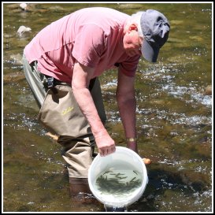
Atlantic salmon stocking 2016
To identify an Atlantic salmon, draw a vertical line behind the eye. This line will always be behind the mouth of an Atlantic salmon. In other salmonoids, the line will intersect the rear of the mouth.
A healthy water shed must contain wild fish that are free to migrate upstream to spawn

